**Albalate, Andre December 12, 2021 TESDA SQL**

**MySQL Exercises**

1. **Create a Database and name it to WorkerDB.**

**Question No. 1**

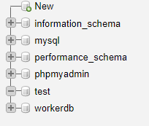

1. **Create a table Worker, Bonus, Title**

**Question No. 2**

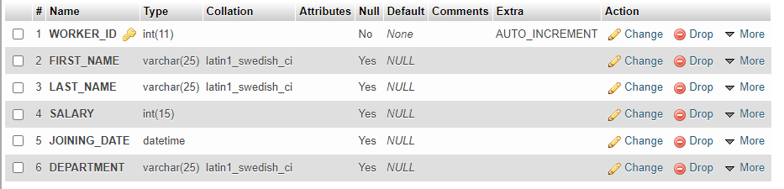

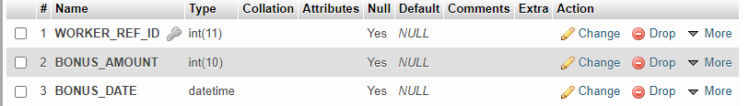

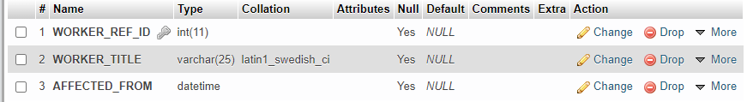

1. **Fill in the table that your created**

**Question No. 3**

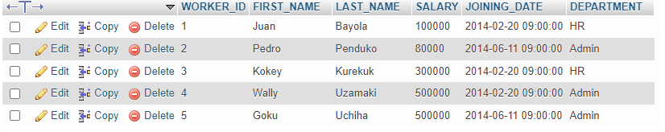

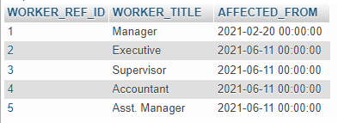

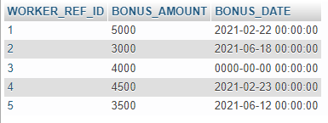

1. **Write an SQL query to print all Worker details from the Worker table order by FIRST_NAME Ascending.**

**Question No. 4**

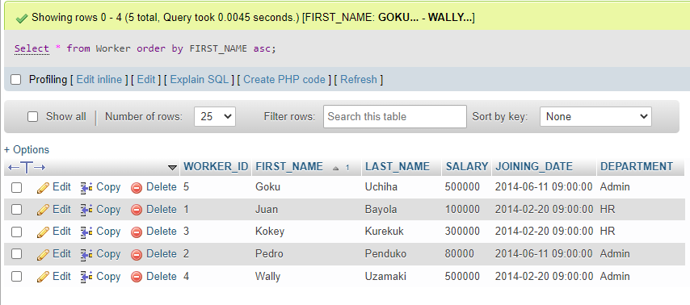

1. **Write an SQL query to print all Worker details from the Worker table order by FIRST_NAME Ascending and DEPARTMENT Descending.**

**Question No. 5**

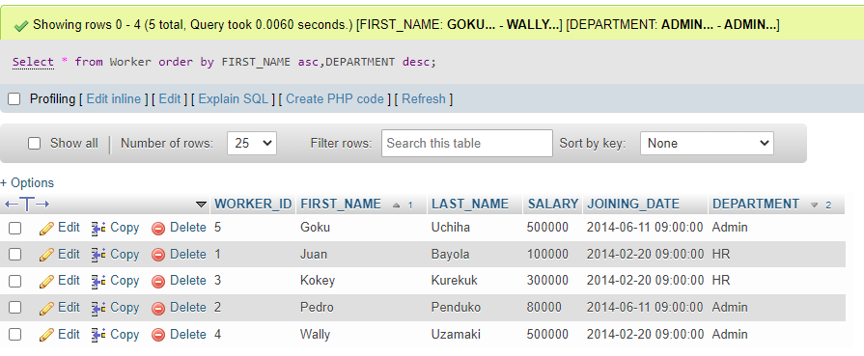

1. **Write an SQL query to print details of Workers with DEPARTMENT name as “Admin”.**

**Question No. 6**

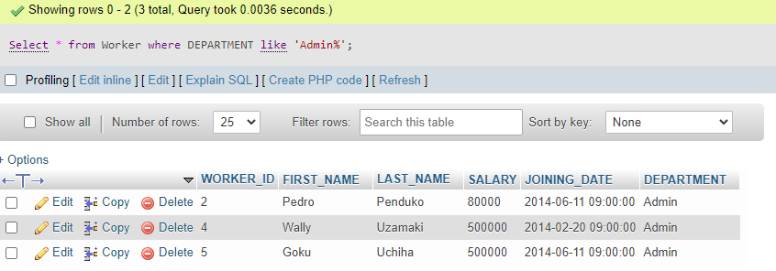

1. **Write an SQL query to print details of the Workers whose SALARY lies between 100000 and 500000.**

**Question No. 7**

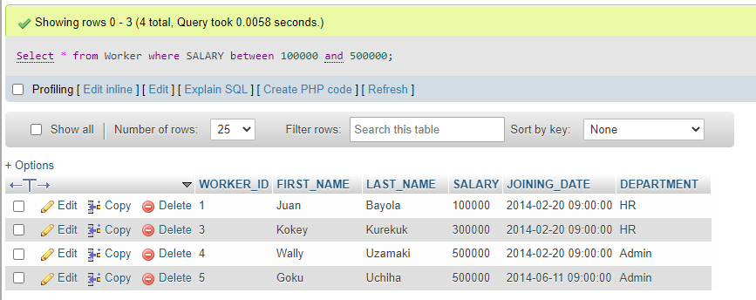

1. **Write an SQL query to fetch the count of employees working in the department ‘Admin’.**

**Question No. 8**

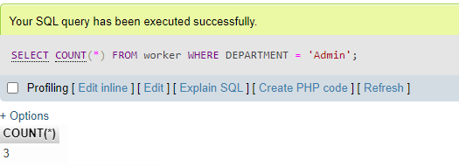

1. **Write an SQL query to fetch worker names with salaries &gt;= 50000 and &lt;= 100000.**

**Question No. 9**

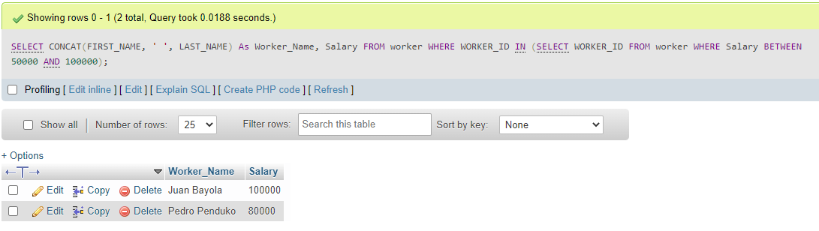

1. **Write an SQL query to show the top n (say 10) records of a table.**

**Question No. 10**

